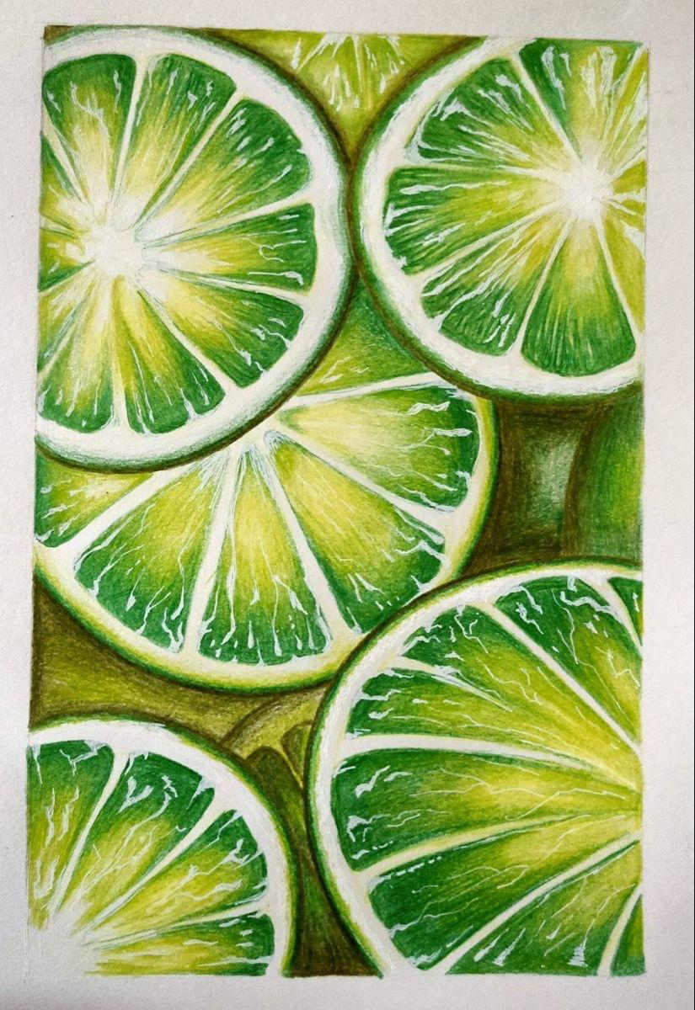

**Assignment 1**

**Pencil colour study**

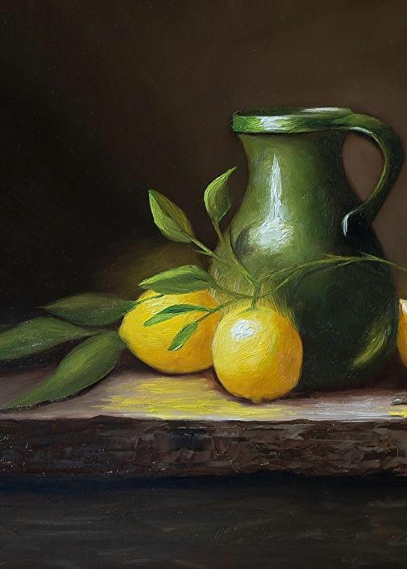

**Assignment 2**

**Pastel study**

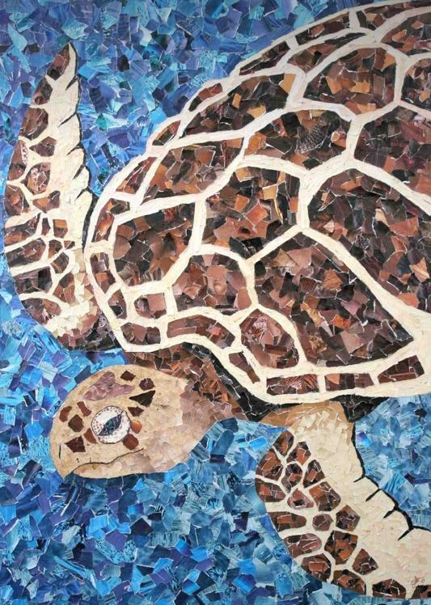

**Assignment 3**

**Collage work**



**Assignment 4**

**Painting**

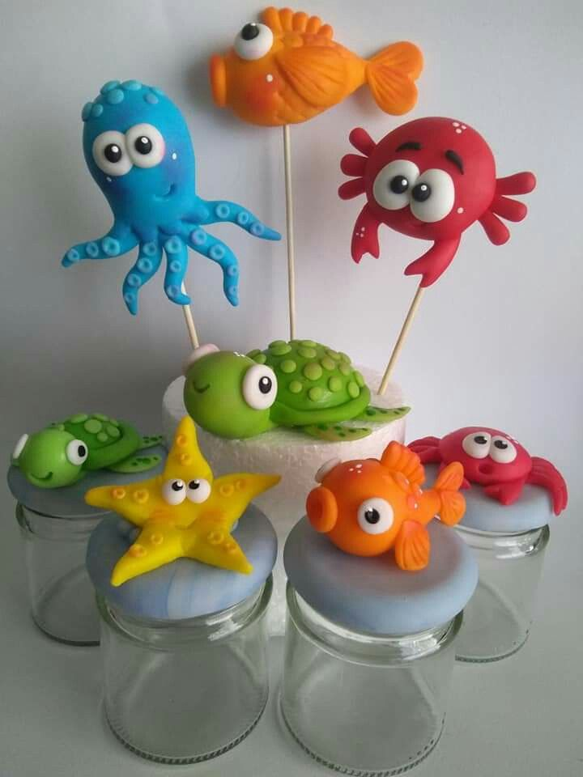

**Assignment 5**

**Play dough work**